Competition Code | Year of Birth | Poem Option 1 or | Poem Option 2
Boys & Girls  SV13 | 2014 | Quicksand  by Carol Ann Duffy. | Who?  By Charles Causley
Boys & Girls  SV14 | 2013 | At the End of a School Day  by Wes Magee | I See You Dancing, Father  by Brendan Kennelly
Mixed  SV15 | 2012 | Hunger  By Robert Laurence Binyon | What is Dying?  By Charles Henry Brent
Mixed  SV16 | 2011 | The Explosion  by Philip Larkin. | P The Second Coming  B William Butler Yeats
Mixed  SV18 | 2010 &  2009 | Quarantine  By Eavan Boland | Best Bone  by Paul Hyland

Feile Luimnigh 2027
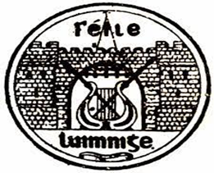
Poetry selection for Senior Section U/13 – U/18
Please note: Only one poem to be performed in each category.

